SOLENT UNIVERSITY   
**Department of Science and Engineering**

MSc (Computer Engineering)

**Software Design and Development - COM714**

**Academic Year 2023-2024**

**Travel Management System**

**Report–**Assignment 1

**Tutor: Dr. Taiwo Ayodele [15/05/2024]**

**Table of Contents**

Introduction 3

System Architecture 3

UML Diagrams 4

Software Development Process 6

Project Implementation 12

Conclusion 16

# Introduction

The project that replaces the paper-based one aims to embed the TMS to modernize the Solent Trips operations. Rather, it will pull all trip-related work together, improve the staff-traveler's communication, and simplify the trip management processes in order to overcome the challenges of travel management by the company. For the trip coordinator, manager, and administrators, as well as the base trip leg, the trip, and the traveler management should be one of the primary functional requirements. TMS strives to cut paperwork up to the extreme, increasing productivity, and thus, coming up with an easy-to-follow procedure, for both staff and travelers by taking advantage of Python as well as following the best practices for software development. The goal of the project at last is to help in solving our customers’ needs and also update our operating standards to the present ones.

# System Architecture

The system architecture consists of three main parts: Traveller Management, Trip Description, and Login & Registration functionalities. These features make the use of the hotel booking application very convenient for consumers. Authentication and new account creating are to be performed in the Login & Registration component. Members can begin the session by either creating an account or logging in with their login information. Users will be granted access to the system's functionalities only and they will be able to do that when they successfully log in. The users would be able to adapt to their trips and go to different destinations using the Trip Description component. Travelers' freedom of choice in terms of things such as what places of interest appeal to them, planning whether it is a solitary trip or not, as well as the sort of hospitality they want makes their journey more enjoyable. This module is designed to work in tandem with any third-party system, by capturing relevant trip information and resources. Users have an option of both customizing their travel preferences and their personal data with the help of the Traveller Management component. Users go to the tab to view their previous travels, update their personal information, and remove unnecessary outdated data. To ensure user privacy and data accuracy for their personal data, this part is used.

The Technology Stack of the system is mainly game Engine, Tkinter for the Graphical User Interface (GUI), OpenCV and Pillow for the image processing libraries, and Python for the system's backend. To enhance modularity and scalability, the system takes advantage of subprocess calls that enable the differentiation of Python scripts into distinct ones for various tasks. Each class represents a different system module in the code snippets provided; it contains GUI elements and procedures necessary to support the functioning of the modules. These classes are connected to provide suitable travel management support to users according to the flow diagrams and system architecture previously produced by diagramming tools such as Draw. io.

# UML Diagrams

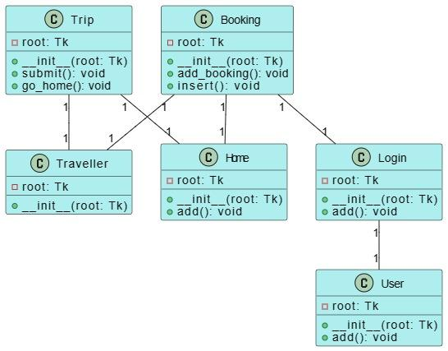

**Figure 1: UML class diagram**

(Source: Acquired from Draw.io)

The given figure shows the travel management system (TMS) class diagram which illustrates how components of the system are interacting and exchanging. A number of important classes make up the system: Booking, Home, Login, User, Trip, and Traveler. All courses possess the specified operations that are relevant to different system components.

The department of managing bookings - adding, deleting, and modifying them - is handled by the Booking class. It is the home class that leads and manages the home screen operations. The login class is used for the registration and authentication of users. Under the umbrella of the user class, system users and their corresponding roles are covered. It is the responsibility of the trip class to control the trip description and any other features attached. Personal traveler data is Traveller class exclusive. The links that connect these castes are revealed in the diagram and can be seen as their forms of communication. While such functionality can be illustrated with other classes like Home, Login, or Traveller, the interaction between classes and modules gives a more holistic understanding of the structure and purpose of the overall system.

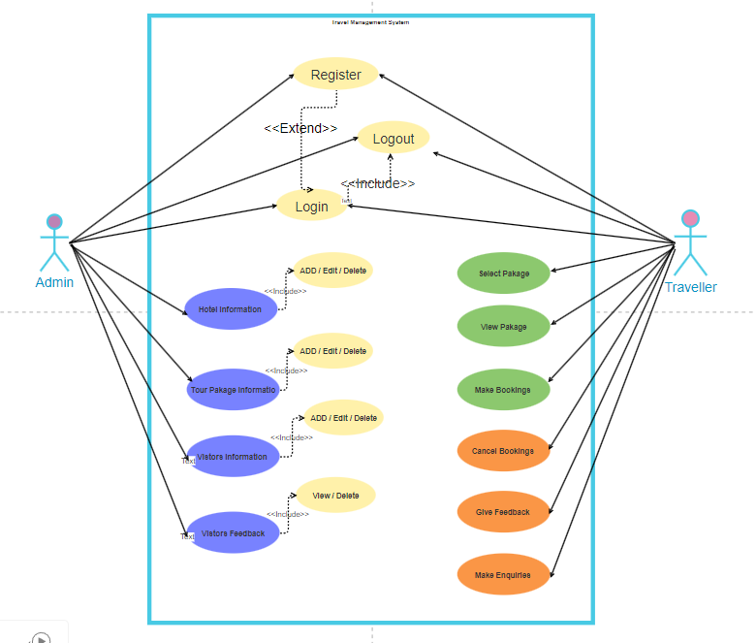

**Figure 2: Use case diagram**

(Source: Acquired from Draw.io)

A use case diagram for a travel management system illustrates various ways actors of the system are involved. Use cases are the features or services that the system offers, while actors represent participants who use or integrate with the system. "T" and "System User" are considered to be the main actors in this travel management system. The System Users can be either staff members or administrators. An actor "Traveller" is capable of accessing, booking the travel, maintaining the data, and finding either pieces of information on the trip. In the meantime, "System User" actor can carry out duties such as organizing the trip, adding new passengers, changing passenger details, and removing passenger records to name but a few. The system provides these use cases to meet the needs of actors which themselves are "Make bookings," "Update Traveller Info," "Manage Trips," and "Search Trip Details. " Visualization of the system's functional requirements and interaction among the various components is carried out using use case diagram in the use case diagram.

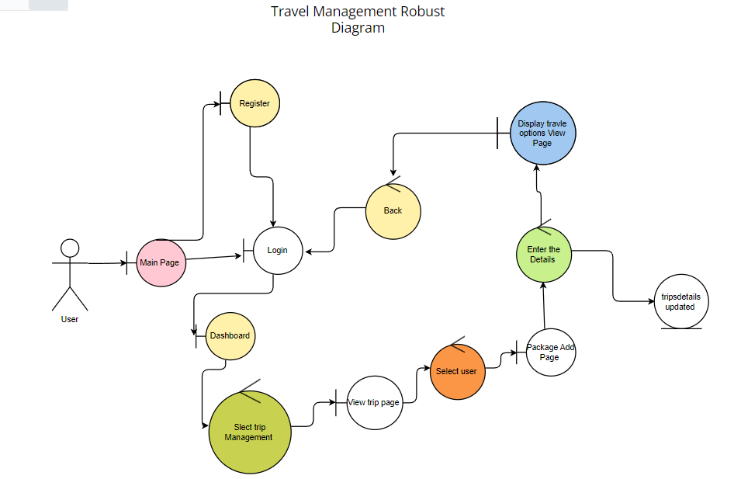

**Figure 2: Robustness diagram**

(Source: Acquired from Draw.io)

The interactions of the system's actors (Traveller, SystemUser, Administrator, TripCoordinator, and TripManager) with the algorithm are shown in the figure below. The user interface (UI) is employed by the macros to initiate activities like trip booking, which include the authentication process and registration. The transportation of these instructions is made to the appropriate controllers that take care of user distinctions and interact with the hidden models. TravellerController object is configured to access traveller data, i.e., to get travellers' information as well as modify it, through use of the TravellerModel object that manages traveller login, logout, and registration activities. Likewise, in addition to the BookingController and TripController which handle actions pertaining to bookings and trips by calling their models, there is a PaymentController that deals with the payments. Specific functions of the system and how they are interconnected are seen in this diagram thus the user will find it easier to grasp its needs and how it behaves.

# Software Development Process

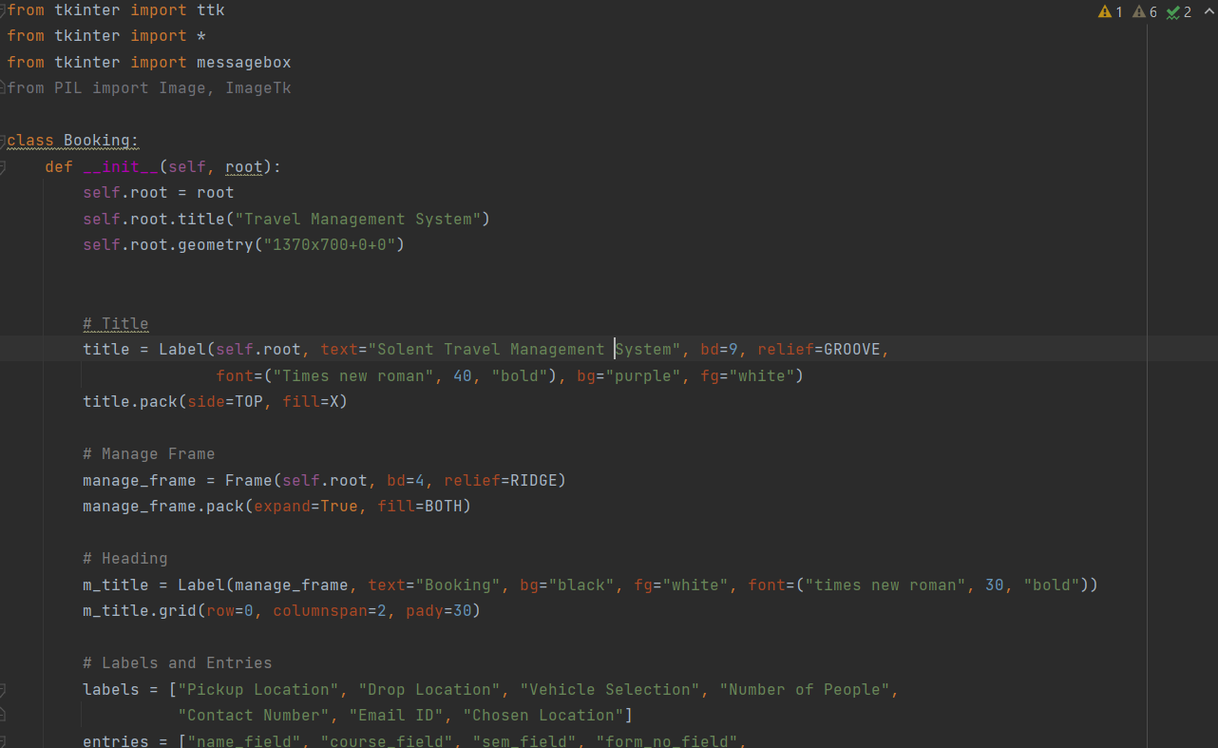

**Figure 3: Booking class**

(Source: Acquired from Pycharm)

This program involves Tkinter to define a class called Booking in a Travel Management Systems hardware. The pops-up interface section of a GUI features booking forms, including destination selection, car selection, and contact detail requirements, pickup and drop locations. Moreover, it has combobox that can select a mode of transport. For instance, the class contains methods to display message boxes conveying the fact that features to be incorporated at addition and insertion of booking data. Once the command is available, the users will be prompted to enter booking details in a GUI window that is being presented. This is exactly how an object of a Booking class is generated. Normally, this program sets the interface of the booking function management system.

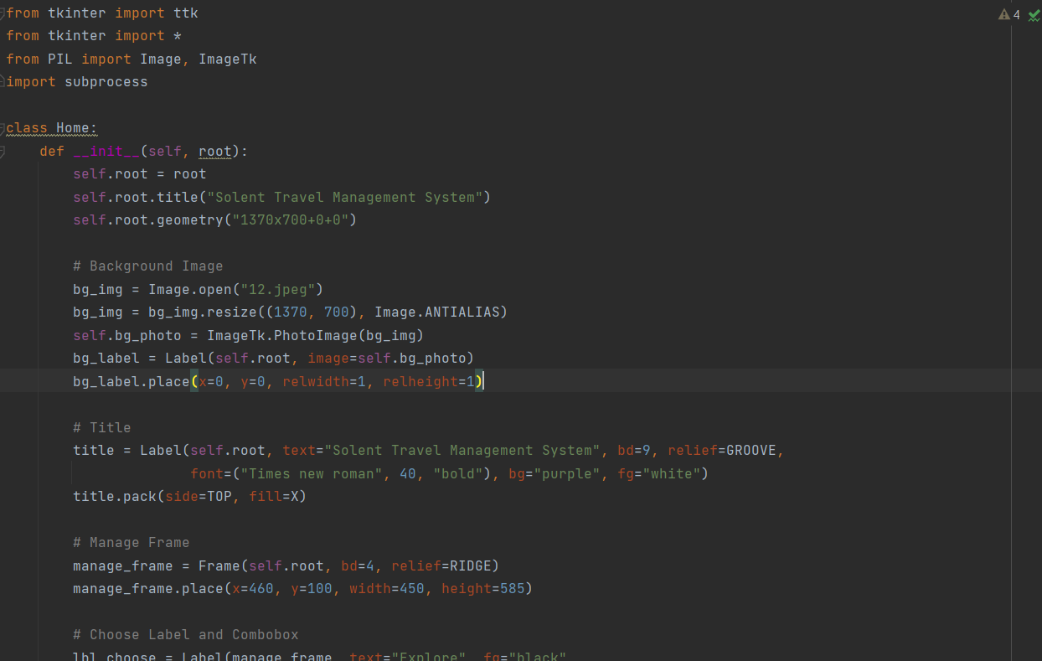

**Figure 4: Home class**

(Source: Acquired from Pycharm)

This code Home.py is the home screen of the travel management system and uses the Tkinter as a library. This displays a window with having title and a background image. It has the ability to go through sections like system users and travelers. These options are embedded with a manage frame. They are found inside a webpage that includes a combo box. It also goes through suggesting the possible travel options and showing a button that can be used for the submission of choices. Once received, it leads to the initiation of a sub-process to run an additional Python script, most likely featuring the traveler login process. This code in general develops the user interface which users can use to navigate through the various system functionalities.

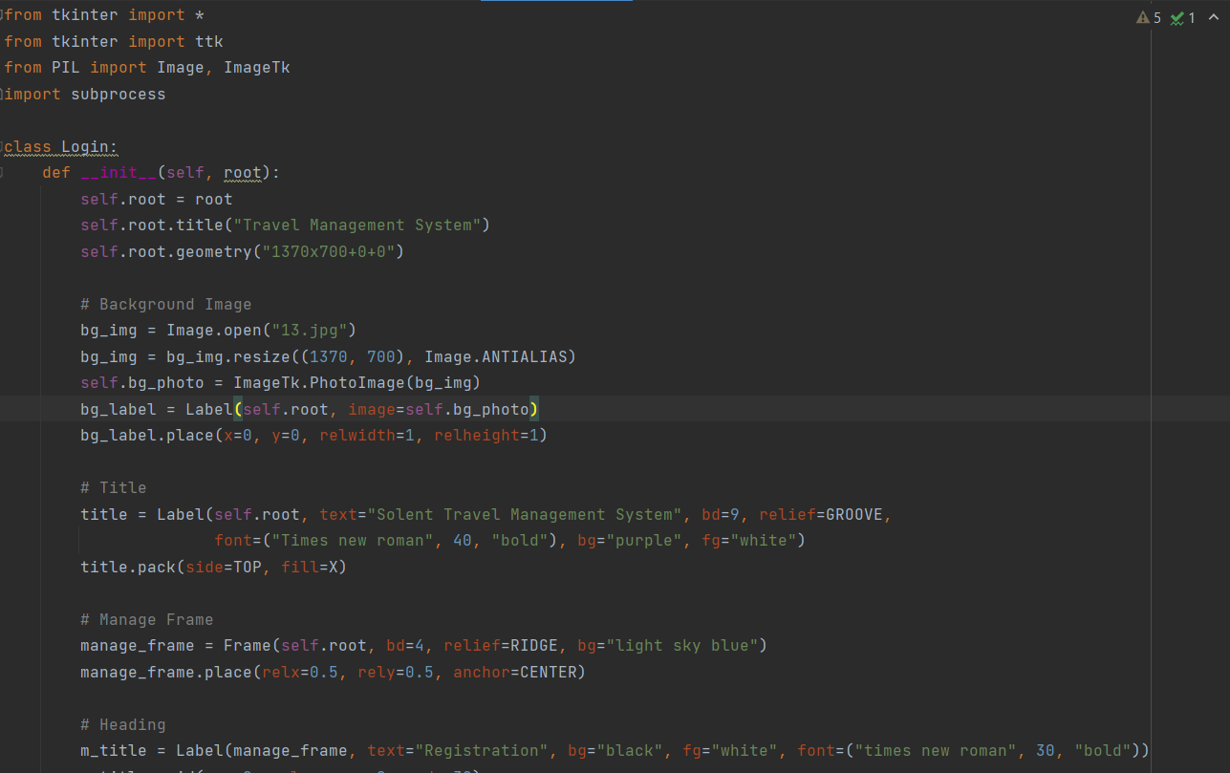

**Figure 5: registration class**

(Source: Acquired from Pycharm)

This code the Tkinter syntax creates an interface used for travel management system registration. Here it is a frame with the title and picture heading. It uses textboxes and combo boxes for the purpose of containing fields where the details of the tourist like name, address, contact, and ID are being included inside manage frames. On the submission of the button, there is a good chance of another Python script in the subprocess being launched mostly for the processing of the registration data. The code, therefore, allows the user interface whereby travelers have to log in and register their data before engaging with the system.

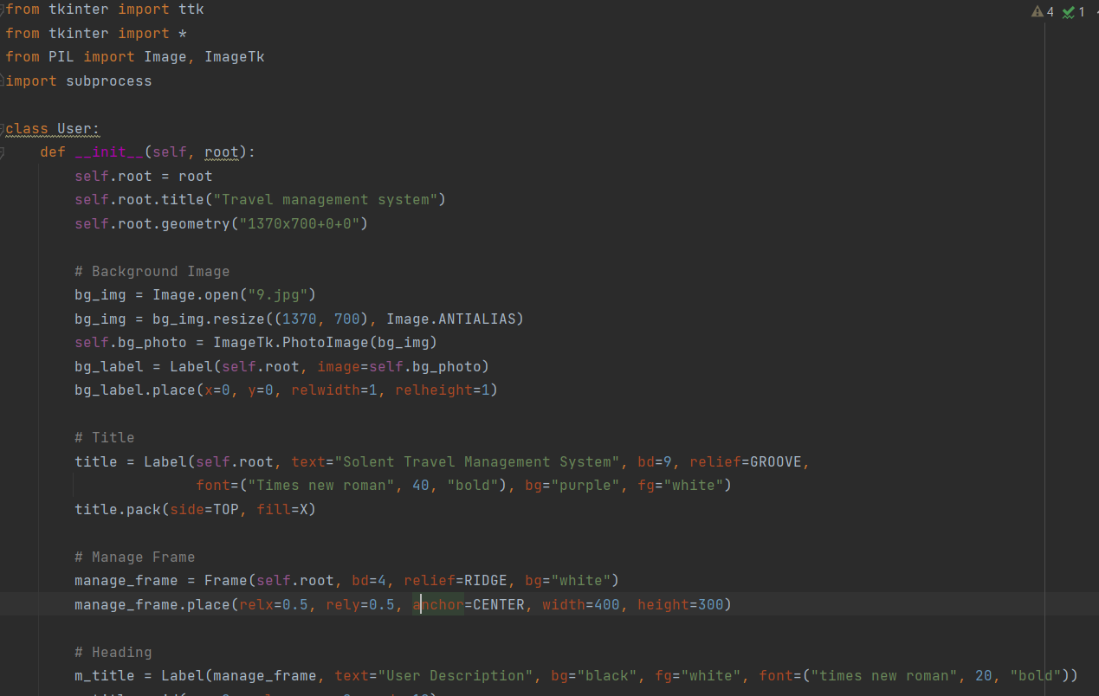

**Figure 6: user class**

(Source: Acquired from Pycharm)

This code is setting a user interface for a travel management system concretely showing different system user types. This window displays a name for a given picture in its title and a highlighted image as background. It has a pull-down menu where managers can select the user's type (Administrator, Trip Manager, Coordinator, etc.) and a label within a frame. There is also the "submit" button that may start the subprocess through different Python script that manages the users. In brief terms, this code extends the usability of the travel management system by enabling user roles to be specified.



**Figure 7: user information class**

(Source: Acquired from Pycharm)

The code utilizeS this to come up with a model that has Tkinter-based user interfaces for logging in and registering with the travel management system. It consists of a window with a title and an image that appears as a background. It has got input fields for the traveller ID, name, and password terms all within a managed box. There are Register New User/Submit Login Credentials Buttons as well as Log in as a System User option. Clicking these buttons initiates a series of subprocesses which may be related to the other Python scripts that actually realize the particular functions. In broad terms, this rule does the controlling of user data input and authentication. As simple as possible.

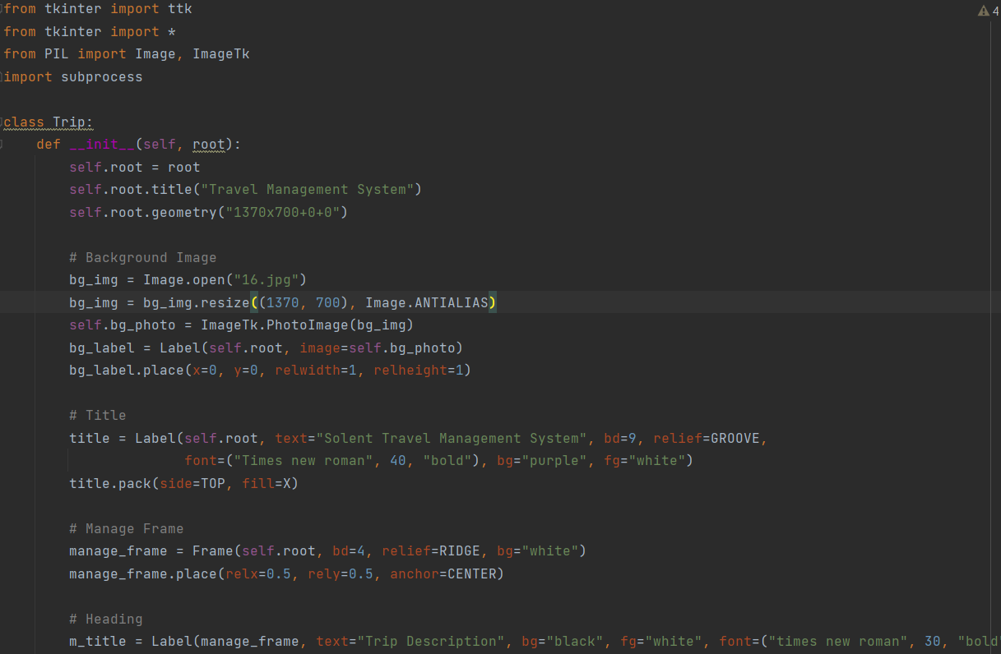

**Figure 8: trip class**

(Source: Acquired from Pycharm)

The code implements a travel management system and in addition graphics user interface evolved for trip descriptions. It has a title bar that displays the title and the image of the background or even an eye dropper to select the background. There are earmarks for point of interest, transfer point, trip type, welcome in a panel, and selecting box for details motion within the box. By clicking the button described here, can either return to the main page or just create a trip description. The trip description window closes when the submit link is clicked but the home button continues to another process after loading the home page. To summarize this clause, the rule becomes a tool for users to be familiarized with the travel management system as well as a precision tool to give details of a trip.

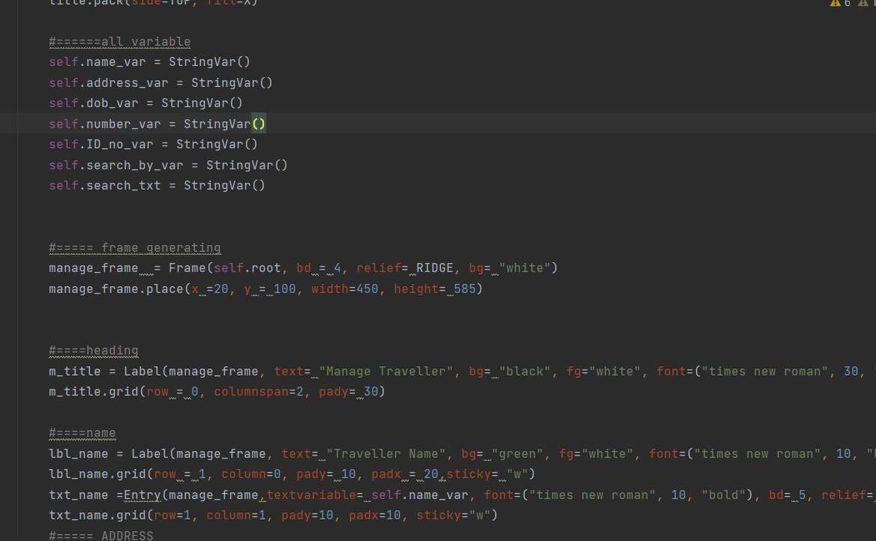

**Figure 9: trip management class**

(Source: Acquired from Pycharm)

In this process of travel management system the following Python code constructs GUI for general operations on travellers' data. There is where information on the traveler can be filled that including name, address, birth date, phone number, ID type, and ID number. Traveler’s records allow users to add, remove, or update records. The aspect of search also takes place in this process and the search is done by name, ID or contact. Two frames make up the interface: one captures the customer data while the other is to show traveler details - for example, check-in time and booking information. The use of images adds more color to the overall appearance of Visual Appeal. Whereas, in the end, the code succeeds in providing a meaningful interface to handle traveler details.

# Project Implementation

**Booking page**

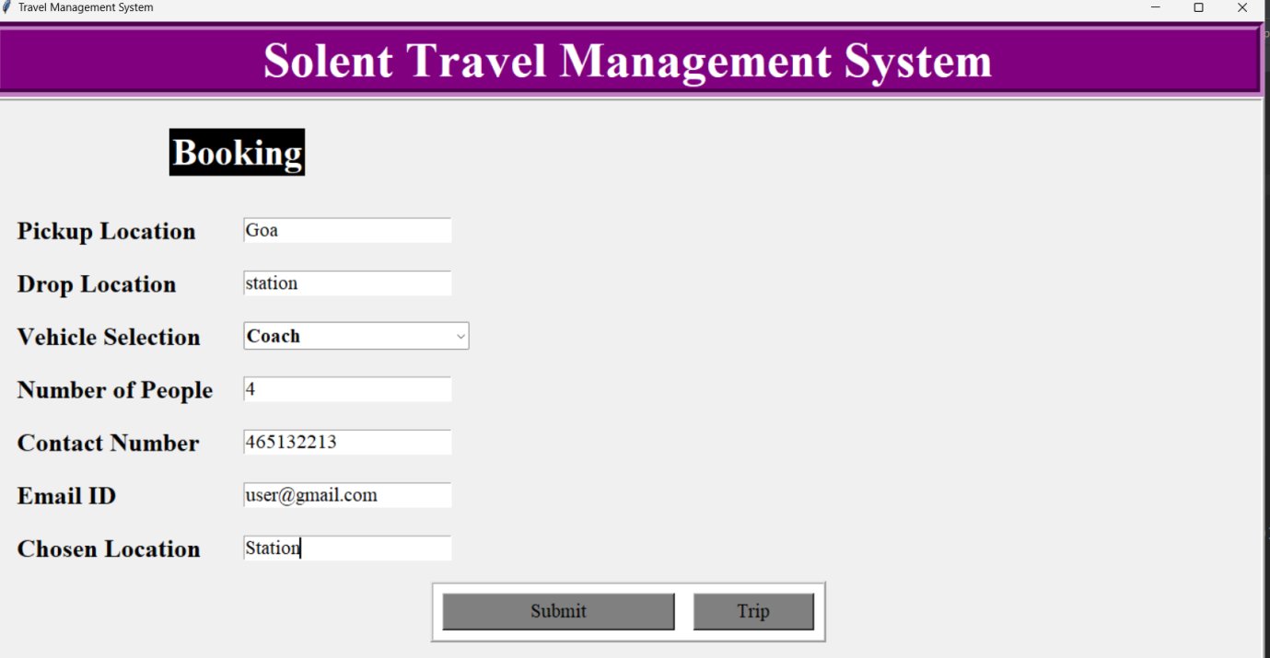

**Home page**

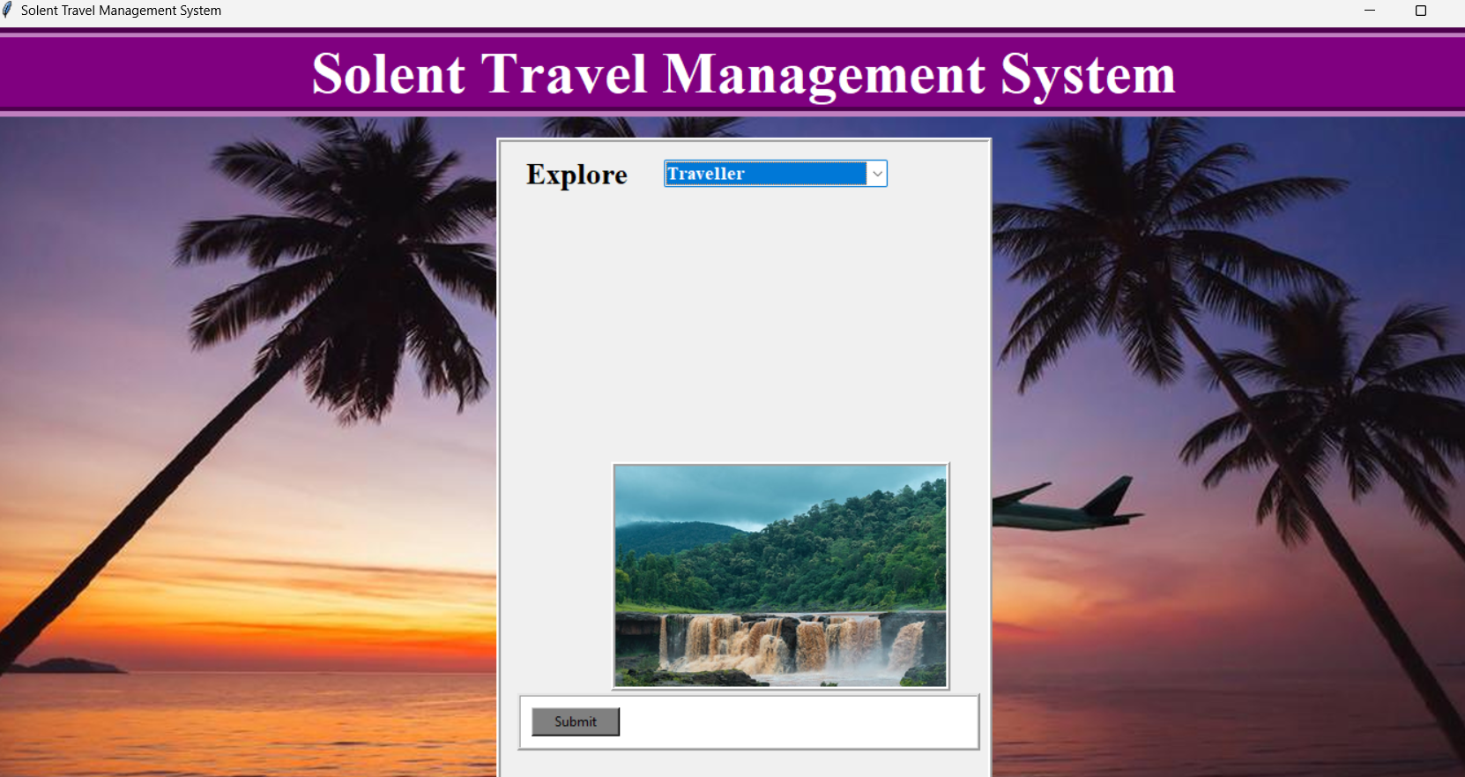

**Login and registration page**

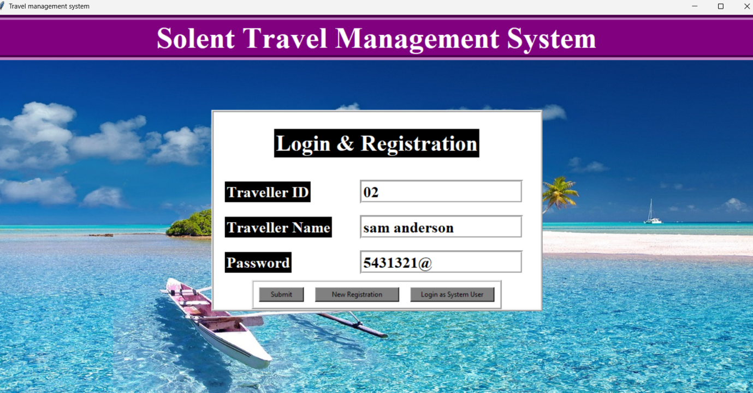

**Registration page**

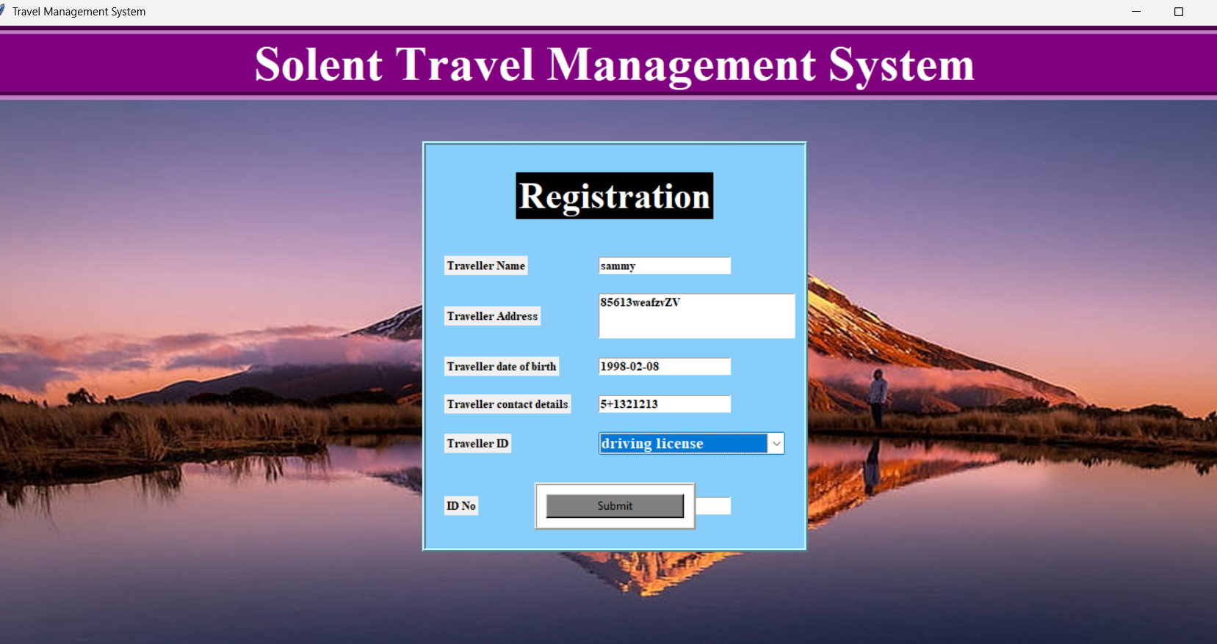

**System user page**

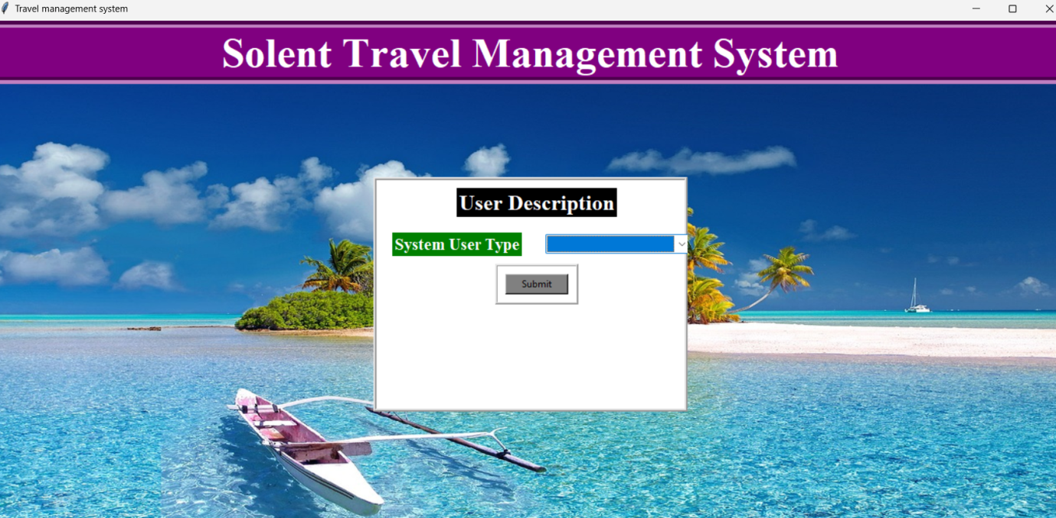

**Trip description**

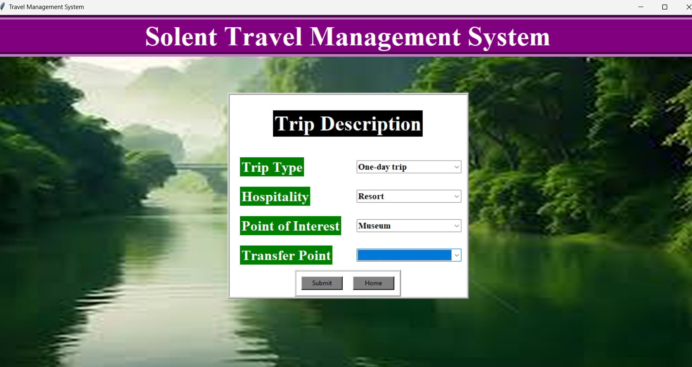

**Managing trips**

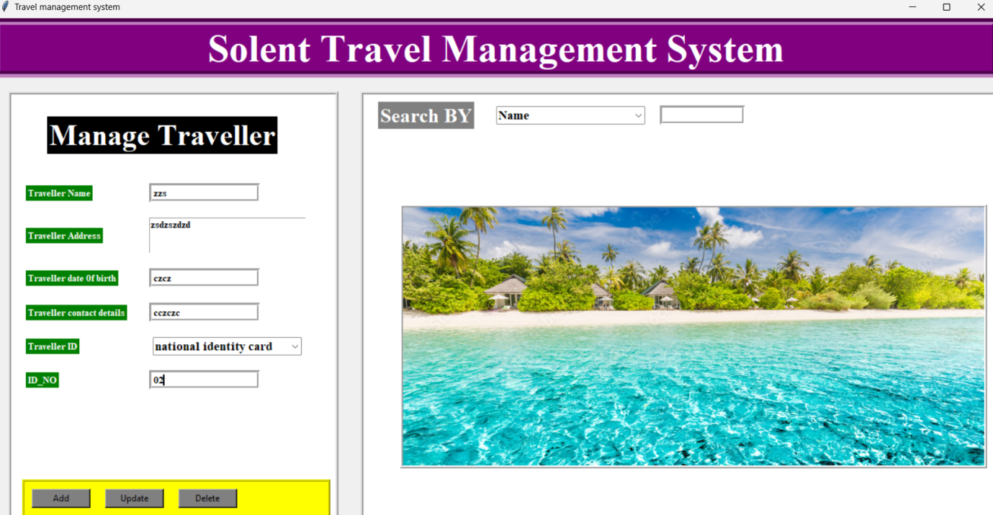

# Conclusion

In summary, the Travel Management System (TMS) takes a holistic set of steps to ensure that the business runs the day to day managerial activities involved in travel. By employing Tkinter, it provides a user interface that allows the passengers to sign-up and book trip schedules with ease. Users can easily process a lot of travel-related tasks thanks to a broad range of unique features, like exploring traveller base, updating their information, booking trips, and managing trip details. There are indeed system modulularity ways through which subprocess that switches between the system parts easily. Storing and retrieval of traveler and trip records are non-optional part of the project as well. Taking all those factors to consideration, TMS boasts numerous advantages for travellers and system users including the intuitive UI, rich functionalities, and data storage.

# Bibliography

Yu, Q. and Yuan, J., 2022. TransBigData: A Python package for transportation spatio-temporal big data processing, analysis and visualization. Journal of Open Source Software, 7(71), p.4021.

Ghiani, G., Laporte, G. and Musmanno, R., 2022. Introduction to Logistics Systems Management: With Microsoft Excel and Python Examples. John Wiley & Sons.

Sun, G., 2020. Symmetry analysis in analyzing cognitive and emotional attitudes for tourism consumers by applying artificial intelligence python technology. Symmetry, 12(4), p.606.